**Chandigarh College of engineering and technology**



Innovative product design 2018

(Department of computer science and engiineering)

**IR remote controlled home automation**

Project report

It is a simple home automation system where the system controls 4 different appliances with the help of a Remote.

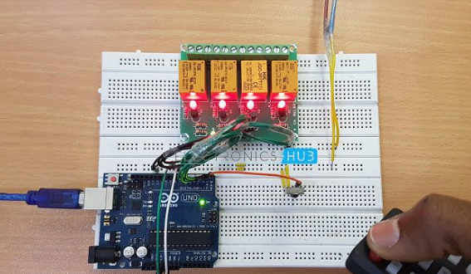 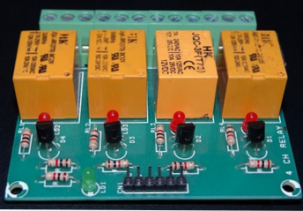

IR based wireless communication is used for controlling different appliances. Arduino is used for controlling whole of the process. Commands are being used for controlling the system by using IR remote. After receiving signal from, Arduino sends related signal to relays which are responsible for controlling home appliances through a relay driver.

As for the working principle, when any button is pressed on IR remote then remote sends a code in form of train of encoded pulses using modulating frequency. These pulses are received by sensor and read by Arduino and then Arduino decodes received train of pulse into a hex value and compares that decoded value with the predefined hex value of the pressed button. If any match occurs then Arduino perform relative operation.

Team Members: Aboli CO17305 ; Parina CO17343 ; Rashika CO17362

Mentors: dr.sunil k singh ; dr.varun gupta ; er.sudhakar kumar